ELDT Messaging for SDLAs

ELDT Message for SLDA websites on/after Feb. 7, 2022

Entry-Level Driver Training
The Entry-Level Driver Training (ELDT) regulations set uniform minimum training standards for entry-level drivers seeking to obtain certain commercial driver’s licenses (CDLs) and CDL endorsements, as established in 49 CFR part 380 subpart F.

Entry level drivers include those applying to:
- Obtain a Class A or Class B CDL for the first time;
- Upgrade an existing Class B CDL to a Class A CDL; or
- Obtain a school bus (S), passenger (P), or hazardous materials (H) endorsement for the first time.

As of February 7, 2022, individuals applying for the above CDL or endorsements must complete the training required by the ELDT regulations to be eligible to take the required CDL skills test or the H endorsement knowledge test.

An applicant who obtained a commercial learner’s permit (CLP) before February 7, 2022, is not required to complete the entry-level driver training for obtaining a CDL, so long as the applicant obtains a CDL before the CLP or renewed CLP expires.

The ELDT regulations apply to all entry-level drivers, except:
- Drivers excepted from the CDL requirements under § 383.3(c), (d), or (h);
- Drivers applying for a restricted CDL under § 383.3(e) through (g);
- Military personnel with military CMV experience who meet all requirements and conditions of § 383.77; and
- Drivers applying for a removal of a restriction in accordance with § 383.135(b)(7).
Note: States may have additional training requirements that exceed the minimum requirements established by the Federal ELDT regulations. For more information on their State’s requirements, CDL applicants can contact their State Department of Transportation, Department of Education, or their local State Driver Licensing Agency (e.g., the Department of
Motor Vehicles).

Entry-level drivers subject to the ELDT regulations must complete entry-level driver training from a training provider registered with the Federal Motor Carrier Safety Administration (FMCSA). For a list of registered training providers, and to learn more about the ELDT requirements, visit the FMCSA Training Provider Registry.

ELDT FAQs
SDLAs may direct applicants to the Training Provider Registry FAQ page: https://tpr.fmcsa.dot.gov/FAQ

Suggested ELDT Social Media Posts
Messaging Focus: Training Provider Registry is Fully Operational

Target Audience: Training Providers, Drivers

For web graphics to accompany posts, see page 4.

Facebook and LinkedIn:

- The Training Provider Registry is now fully operational and mandatory use is in effect.
Individuals seeking to apply for a Class A or Class B CDL for the first time, upgrade their Class B to a Class A CDL, or apply for a P, S, or H endorsement for the first time must now complete the training required by the Entry-Level Driver Training (ELDT) regulations before being permitted to take the required skills or knowledge test.
Individuals seeking one of the licenses or endorsements above must use the Training Provider Registry to search for a registered training provider.
All entities that provide entry-level driver training must be registered in the Training Provider Registry and use it submit driver training certification records within two business days of a driver’s training completion.
Learn more: https://tpr.fmcsa.dot.gov/
- Registration for the Training Provider Registry is open for providers that provide entry-level driver training that meet applicable Federal and State requirements. This includes training for Class A and Class B CDLs and the school bus (S), passenger (P), and hazardous materials (H) endorsements. Training providers that have registered with FMCSA are listed on Training Provider Registry. Learn more:
https://tpr.fmcsa.dot.gov/Provider

- Training providers: If you provide training for entry-level CDL drivers, you must register in the Training Provider Registry. Registration requires that you self-certify that your program meets applicable Federal and State requirements Visit the Training Provider Registry to learn more and register: https://tpr.fmcsa.dot.gov/Provider

Twitter:

- The Training Provider Registry is now fully operational and mandatory use is in effect. Learn more: https://tpr.fmcsa.dot.gov/
- Individuals seeking to apply for certain CDLs and endorsements must now complete entry-level driver training before taking a CDL skills or knowledge test. Learn if you are subject and more at https://tpr.fmcsa.dot.gov/
- Do you need to search for an entry-level driver training provider? The interactive search feature is now available on the Training Provider Registry. Start your search at https://tpr.fmcsa.dot.gov/
- All entities that provide entry-level driver training must now submit certification of training completion to FMCSA using the Training Provider Registry. Learn more: https://tpr.fmcsa.dot.gov/
- If you train CDL drivers, you may need to register with FMCSA. Learn about Federal Entry-Level Driver Training regulations and how to comply. https://tpr.fmcsa.dot.gov/Provider

- Do you train CDL drivers? You may need to register with FMCSA. Learn more about Federal regulations and how to comply. https://tpr.fmcsa.dot.gov/Provider

- Training providers must register on the Training Provider Registry to train entry-level drivers. https://tpr.fmcsa.dot.gov/Provider

- Registration for the Training Provider Registry is open for training providers. Learn more and register today. https://tpr.fmcsa.dot.gov/Provider

- If you train CDL drivers, you may need to register in the Training Provider Registry. Registration is required to provide entry-level driver training required by FMCSA’s regulations. https://tpr.fmcsa.dot.gov/Provider

- Registration in the Training Provider Registry is required for entry-level driver training providers. Are you registered? Know your ELDT requirements and register today. https://tpr.fmcsa.dot.gov/Provider

Web/social media graphics

Click each image thumbnail below for a link to download the web-ready PNG image file.

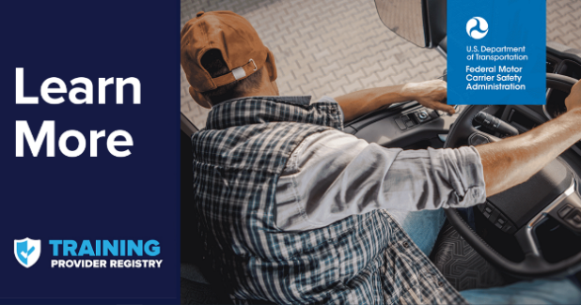 | 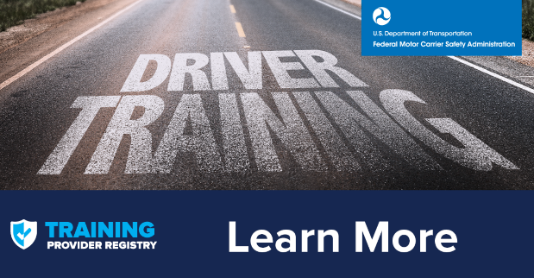
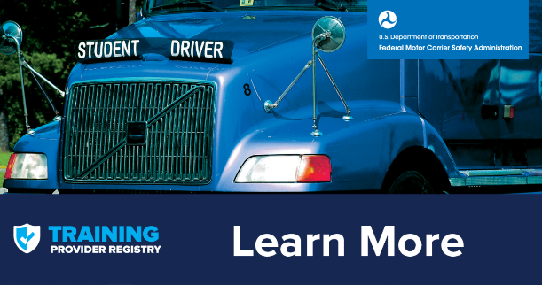 | 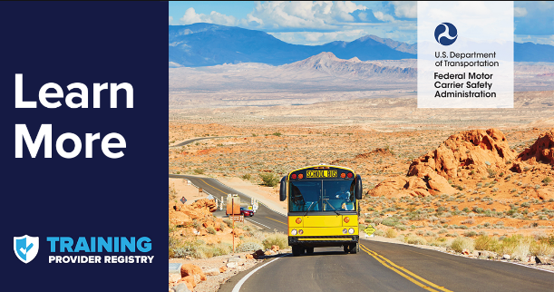
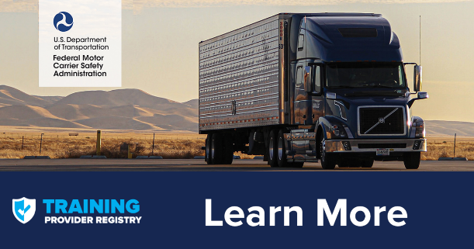 | 